

9B21A024

Bald Baker’s Sweet Challenge

Dr. Ebrahim Mazaheri and Dr. Maryam Tofighi wrote this case solely to provide material for class discussion. The authors do not intend to illustrate either effective or ineffective handling of a managerial situation. The authors may have disguised certain names and other identifying information to protect confidentiality.

This publication may not be transmitted, photocopied, digitized, or otherwise reproduced in any form or by any means without the permission of the copyright holder. Reproduction of this material is not covered under authorization by any reproduction rights organization. To order copies or request permission to reproduce materials, contact Ivey Publishing, Ivey Business School, Western University, London, Ontario, Canada, N6G 0N1; (t) 519.661.3208; (e) cases@ivey.ca; www.iveycases.com. Our goal is to publish materials of the highest quality; submit any errata to publishcases@ivey.ca. i1v2e5y5pubs

Copyright © 2021, Ivey Business School Foundation Version: 2021-07-26

“Pure sugar is one molecule away from pure cocaine,” said Dan Sennet, founder and chief executive officer of Bald Baker. “As consumers, we should feel worry-free culinary happiness, but unfortunately, it is a struggle for far too many,” he continued. Sennet’s company, Bald Baker, aimed to revolutionize the dessert industry by fulfilling consumers’ sweet-tooth cravings⎯without the use of sugar.

It was a snowy afternoon in January 2019, and Sennet was thinking about the future of the company. Bald Baker was going to receive a CA$50,000[1] grant, and Sennet was planning to use it for marketing. He knew that without a clear positioning and targeting strategy, he would not be able to use the grant efficiently. He would receive the grant in one week and needed to soon decide how to allocate the grant funds to various marketing activities.

HISTORY OF BALD BAKER

After graduating with a bachelor of business administration degree from Wilfrid Laurier University (WLU) in Waterloo, Ontario, Sennet moved to New York City to start a career in finance, all while searching for an “aha” moment that would present him with an opportunity to apply his entrepreneurial spirit.

As with many entrepreneurial ventures, Bald Baker had arisen from personal experience. In late 2015, Sennet and his family had been enjoying a vacation in New Orleans until the evening that his father experienced a terrifying glycemic shock within 30 minutes of finishing dinner. Witnessing his father stumbling in front of him and losing control of his body, Sennet could not make sense of what was happening. It turned out that his father had eaten something that had caused his blood glucose levels to peak, and as he had type 2 diabetes, this inevitably left him in a health crisis. In that moment, Sennet realized that he had to bridge the gap for individuals like his father who wanted to live “normal” lives and eat like everyone else⎯not worrying about consequences. But with diabetes, that was impossible. With 80 per cent of foods containing added sugar,[2] the substance was almost impossible to avoid, making the acceptable remaining options for a diabetic undeniably limited. With that realization, Sennet had experienced his “aha” moment.

In December 2016, Sennet decided to move back to his hometown of Toronto to pursue a new venture, helping individuals enjoy the “sweet” pleasures in life without the health risks. The young entrepreneur used his finance training and business knowledge from the Lazaridis School of Business and Economics at WLU to analyze the issues consumers faced when wanting to purchase health-conscious desserts.

Once Sennet had established his ideas for the venture, he needed to address how he was going to get his operation up and running, knowing that his lack of experience in baking and limited understanding of the consumer packaged goods industry would present challenges. Building meaningful connections throughout the development of the business was crucial. He believed that “if you aren’t the expert in something, find the person who is.” Through his friends, he was introduced to Michelle Rosenstock, a lawyer by training and a food connoisseur at heart. Rosenstock could immediately envision Sennet’s ideas, and she shared with him her strong understanding of the health-conscious food industry and target consumer. She advised Sennet to revise his product strategy from being solely low sugar to being low sugar, vegan, and gluten free, in order to stay on top of market trends. Soon enough, Sennet was convinced that Rosenstock’s network connections in Toronto and her knowledge of the market could bring Bald Baker’s treats and mission to life. Thus began a new professional relationship for Sennet.

Consequently, Rosenstock immediately got to work by creating three cookie recipes for Bald Baker’s product line, leaving Sennet to focus on website development, marketing, and related launch plans. Within three months of officially starting the company on January 1, 2017, Sennet positioned Bald Baker as a sugar-conscious, vegan baking company.

In April of 2017, Sennet officially launched Bald Baker at the Niagara Food & Wine Expo in Niagara Falls, Ontario, with the goal of receiving market feedback from consumers to determine whether the business was a feasible idea⎯or whether he should not have quit his day job. Substantial difficulties lay ahead for Bald Baker, many of which revolved around the relatively small market size from consumer food shows. Sennet tasked himself with determining the demographics and buying behaviour of attendees at the food shows, as this would give him a realistic outlook on any further investments needed to grow Bald Baker.

Aside from operational challenges, Sennet had to clarify his personal involvement in Bald Baker. As a married father, Sennet had high personal expenses, and he had a skill set that would allow him to enjoy a very stable and lucrative position in the finance industry. However, he felt an internal drive to reconnect people like his father with life’s simple joys, through health-conscious, satisfying, and delicious treats. Besides this, with Bald Baker’s treats at the consumer food shows receiving very positive reviews, the company was beckoning him. The market opportunity was significant, and it seemed to him that the funds for the business could largely be externally generated.

RISE OF THE LOW-SUGAR and VEGAN DESSERT MARKET

According to Statista,[3] the sales value of cookies in Canada had grown from $726 million in 2013 to over $813 million in 2018. The competition was intense in this industry, with a few major competitors, such as Weston Foods (Canada) Inc, Kellogg Company, and Mondelēz Canada, controlling the market. Bald Baker differentiated itself by offering cookies that were not only low in sugar, but also vegan and free of nuts and dairy. This offering was consistent with the demand for healthier snacks in the market.

By early 2017, the health-conscious trend of plant-based foods had come of age. Vegan and plant-based foods had become ubiquitous in the mainstream retail and food environment as consumers were inundated with choices at grocery stores and through online retailers. In 2018, a Nielsen Global survey reported that 23 per cent of consumers wanted more planet-based products.[4] Looking at the food market in 2016, it was hard to imagine that plant-based foods had been around for over three decades. In the 1980s, Dr. T. Colin Campbell introduced the term “plant-based diet” to define a low-fat, high-fibre, and vegetable-based diet.[5] The closed-loop vegan market had grown from being unknown in the 1980s to becoming a massive enterprise in the late 2000s. Since 2017, the market had been growing at a considerable pace, and the sugar-free market in North America was estimated to reach US$73 billion by 2021.[6] Many treats were advertised in the market as healthy, vegan, gluten free, and high quality; however, many of these products were filled with sugar or were low-sugar products of low quality.

According to Diabetes Canada, one in three Canadians was living with diagnosed diabetes or “pre-diabetes,” and as many as 60 per cent of Canadian adults were overweight or obese.[7] Further, growing cases of diabetes, insulin-resistance, and obesity in the majority of the population signified that the general health of consumers was deteriorating and therefore was in urgent need of support.[8]

Sugar had drug-like addictive properties that enabled people to indulge in it irresponsibly.[9] According to the United States Department of Agriculture, the average American consumed between 150 and 170 pounds of refined sugar a year.[10] Sweeteners began replacing sugar in people’s diets, with products designed to replicate the taste experience of sugar but without the same impacts. Of note, two US companies had created sweeteners that were proving to be extremely popular and were “generally recognized as safe” (GRAS) for use in food products: the first was branded under the name Sola and the second was known as Lakanto. These sweeteners contained 75 per cent fewer calories than sugar and, most importantly, unlike sugar, neither created the blood glucose response that sugar did. The ingredients contained natural sweeteners: monk fruit; stevia extracts; and sweeteners known as sugar alcohols or polyols, including erythritol and maltitol, which were derived from fermenting lactose, glucose, or sucrose.[11] However, Sennet indicated that the problem with these sweeteners was that they contained ingredients that were not allowed to be used in Canada, even though they were far superior to the sugar alternatives permitted in Canada, such as Splenda. Sennet was forced to use ingredients that simply were not as good as those used by his competitors in the United States.[12] Obviously, his company was at a disadvantage if Sennet wanted to play by the rules.

The low-sugar and vegan product category was characterized by health-conscious consumers who consistently searched for products presented as healthy and convenient options. With snacking becoming increasingly popular,[13] consumers were looking for health-conscious snacks to fulfill their cravings for something sweet. According to Sennet, the low-sugar and vegan food category was a challenging one to manage: “Consumers are picky. If a brand doesn’t work, they move on; if a new format or brand is introduced, they want to try it immediately. Currently, consumers want to feel good about what they indulge in, rather than worrying about how that one dessert will negatively impact their health.”

BALD BAKER TODAY

Product

The Bald Baker product line included three cookies (the Nutty Chipster, the Sweet and Salty Cookie, and the Oat to Joy) and one classic brownie (see Exhibit 1). Products were offered in a variety of flavours in order to satisfy consumer preferences. The cookies were wrapped individually and sold in packs of six (Kraft Box) or 14 (Retail Box). The vast majority of retailers sold the products individually out of 14-pack retail merchandise boxes.

Over time, Sennet had invested time and resources in creating and maintaining a clear image for Bald Baker with key brand values focusing on the following six values:

* Sugar conscious: Bald Baker used four grams or less per cookie of non-glycemic-impact erythritol and stevia to sweeten the products.
* Gluten free: Sennet focused on using high-quality, nutritious plant- and legume-based flours⎯such as almond, pecan, and quinoa⎯that imparted moisture, the proper texture, and taste into all of the products.
* Egg free: The binding and textural effects of eggs were replaced in the products with an all-natural vegan substitute called a “flax egg,” which was golden flax meal combined with water.
* Dairy free: Unrefined coconut, sunflower, and canola oils were used in the products instead of butter. Not only were these healthier fats, with many benefits including boosting metabolism, but these oils added wonderful flavour to the products.
* Vegan: Bald Baker produced 100 per cent plant-based products that could be enjoyed by those who did not consume animal products.
* Worry free: Bald Baker kept consumers’ enjoyment and health in mind to create nutritious and delicious desserts that could be enjoyed at any time, without regret or concern.

Currently, Bald Baker could produce 2,500 units per day. It was most economical to produce 2,500 units of just one stock-keeping unit, as this allowed the company to decrease the cost per cookie significantly.

Consumers

Originally, Bald Baker had intended to focus on the diabetic population by baking low-sugar cookies. But Bald Baker’s chief cookie officer, Rosenstock, had transformed Sennet’s cookies by making them gluten free and vegan in addition to low sugar. By sheer coincidence, the company’s use of low-glycemic flours meant its products were acknowledged by people following a specific diet known as “ketogenic” (keto) almost immediately after launching. This diet had a massive group of followers, and this generated a significant amount of revenue for Bald Baker. With a great product, Sennet wondered, “Who do I sell these cookies to and how do I sell them?”

The target demographic for Bald Baker was very similar to that of other health-conscious products. According to Sennet,

Instead of focusing on people with diabetes, being in business for more than a year has shown me that I’m primarily generating revenue from 25−44 year-old women who consider themselves some combination of keto, vegan, gluten-free, and/or more broadly speaking, health conscious. The 35−44 year-olds are active users of Facebook and the 25−44 year-olds are active users of Instagram; they are the type who are grounded in their everyday realities of life, hyper aware of food trends, intelligent about their culinary choices and who may be looking to make a change in their diet or lifestyle. As a young entrepreneur that is relatively cash-strapped, you have to follow where the money trails . . . so, who is bringing the money? These demographics⎯who are either one or all of the following: vegan, gluten-free, and ketogenic⎯are attracted by the fact that our products are low-sugar as well as vegan and/or gluten-free. Many industry professionals tell me to stay away from the diabetic market because broadly speaking, the mass diabetic market is [generally on the low end of the]income scale and [has a] low propensity to spend on luxury goods. But my original assertion is that nobody is targeting the largest population of them all: diabetics. There simply just aren’t any high-quality, low- or sugar-free products on the market.

Given the recent market trends, Sennet wondered whether the current consumer and product positioning was adequate for the long-term growth and sustainability of the brand. While there could be other consumer segments with potential, Sennet realized that moving the brand away from the initial target market⎯diabetic customers⎯could also involve significant risks.

Competition

Bald Baker competed directly with two producers of health-conscious and low-sugar products: home bakers who had severe allergies and therefore insisted on baking their own treats, and companies producing healthy, high-quality snacks. These companies included Sweets from the Earth,[14] New Moon Kitchen,[15] and Shockingly Healthy[16] (see Exhibit 2 for a competitor analysis summary).

The Toronto-based company Sweets from the Earth had been named as one of Canada’s fastest growing companies.[17] The company had two product lines. The first product category was distributed locally, owing to the fact that the products had a short shelf life of three months. Its second line of products was traditional consumer packaged goods with a longer shelf life, distributed using an intermediary food distributor that had access to the entire Canadian market. Sweets from the Earth sold two diversified categories of products: (1) peanut and nut free and (2) gluten free. Both categories consisted of cookies, cheesecake, frozen cookie dough, loaves, muffins, squares, brownies, bars, and other treats.[18] The company’s product lines were constantly expanding, often due to suggestions and feedback from the company’s valued customers. Although the company used unrefined sugars, the sheer volume of sugar in the cookie created a very unfavourable glycemic impact that a sugar-conscious person would want to avoid.

New Moon Kitchen was another local, Toronto-based company marketed for consumers across the spectrum of food allergies and sensitivities and of lifestyle choices. Its product line consisted of nine cookies, one granola bar, and one health bar.[19] The products were vegan, nut free, peanut free, trans-fat free, and gluten free. The company baked its products using wholesome ingredients in small batches, to keep the freshness intact.[20] The brand stood out as a product that tasted delicious and was good for the consumer. New Moon Kitchen’s retail prices were similar to those of Bald Baker.

Shockingly Healthy shared values similar to Bald Baker’s—fulfilling consumers’ “desire to eat dessert regularly in a way that was healthy and empowering, rather than energy zapping, guilt inducing, and waistline expanding.”[21] Its product line was whole-food based, infused with natural sweeteners and health-promoting ingredients, and contained a controlled amount of sugar.[22] Shockingly Healthy could be found at over 100 retailers in the Greater Toronto Area and throughout Ontario, including Whole Foods, Nature’s Emporium, Balzac’s Coffee, Pusateri’s, and many neighbourhood coffee shops.

Price

Bald Baker products were shipped and sold directly to retailers in cases, with varying numbers of cookies/brownies per case. Bald Baker’s regular listing price was $1.80 per cookie, and the manufacturer’s suggested retail price was $2.99 per cookie. Retailers suggested promotional spending per case to incentivize purchasing, and so Bald Baker’s promotional activities included feature pricing (the manufacturer’s suggested retail price less a discount). Bald Baker provided a feature selling price of $1.65, while the retail feature price was $2.69 per cookie; this price reduction allowed retailers to sell the cookies at the featured price. Consumers responded well to in-store price promotions and to any instances when the products were sold outside of the normal shelf location, such as at end-of-aisle displays, which drove additional sales volumes. Bald Baker sold about 40 per cent of its products at the feature price to the retailers.

The competitors sold their cookies in individual packages that ranged in price from $1.49 to $2.99 for a same-sized package.[23]

Bald Baker’s ingredient, production, and miscellaneous and packaging costs were $0.32, $0.32, and $0.18 per cookie, respectively, and the cost of returned/damaged units was expected to be 2 per cent of gross revenue (see Exhibit 3 for an idea of the number of units sold in 2017 and 2018).

Distribution

Bald Baker had established significant listings in Ontario without the use of a traditional food distributor,[24] and its products were found at retailers such as Fiesta Farms, Noah’s Natural Foods, Essence of Life Organics, Ambrosia Natural Foods, and Nature’s Emporium. Bald Baker was also available in a few branches of Sobeys Inc. and Metro Inc. grocery stores through a program that supported local business and did not charge slotting fees (which were negotiated between the retailer and the manufacturer to ensure prominent product placement on the shelf). Other grocery stores, including other Sobeys Inc. and Metro Inc. stores, either did not have the local program and/or charged slotting fees that were not yet affordable for Bald Baker.

Moreover, the brand had established a digital presence in the e-commerce market through online retailers such as Switchgrocery.com, Well.ca, and Penguinfresh.com. Sennet delivered the products himself to keep the cost low; the intermediary food distributors required a 25 per cent markup on the selling price. He knew that, as his business grew, he might have no choice but to use distributors. The distributors had key accounts with retailers that would very quickly enable Sennet to achieve his growth goals. An account manager was assigned to each retail buyer with the responsibility of developing programs to support Bald Baker’s brand at the retail level.

As they did with most consumer packaged goods, account managers played a role in the food category. According to Sennet, “Account managers are responsible for developing strong relationships with the buyers and retailers, therefore becoming the main point of contact for all of their own brand development and following the major category developments and trends.”

With a distributor relationship, retail shelf space for Bald Baker would be negotiated between an account manager and the retail buyer and would be allocated based on several factors, including the recent sales performance of the brand, entrance of new competing products, and support levels for the brand (e.g., co-operative advertising, slotting fees, and promotions and discounts offered). There was no guarantee of performance or sales, and in fact, any product not sold by the expiry date had to be guaranteed by the manufacturer, not the distributor. Similar to most consumer packaged goods, products in the food category were subject to slotting fees from retailers. It was a very expensive way to grow, but it could be entirely worth it.

It was becoming increasingly challenging to acquire retail shelf space, which was dominated by established brands in the health-conscious category. Sennet was considering international market entry opportunities, specifically in the United States, in a few years⎯after the brand was established in Canada. According to Sennet, “In order to enter the United States or any market outside of Ontario, I need to have high capital to invest and [a] much longer shelf life of at least six months for Bald Baker’s products, instead of the three-month shelf life our products currently have.”

Having a product that had clean ingredients and avoided artificial flavours and preservatives posed a natural barrier but was a positive attribute that resonated with his consumers; the consequent shelf-life dilemma was unavoidable. Sennet knew, though, that the real money to be made was in the United States.

Promotion

Due to a lack of financial resources, Sennet had not set a fixed marketing budget. In total, he had spent about $2,000 on advertising, free samples/gifts, and public relations over the last two years. Explaining the company’s advertising, Sennet said, “Bald Baker is advertised as sugar conscious; we purposefully don’t call ourselves sugar free because that evokes a strong mental reaction about the assumed taste or quality. Sugar conscious: seeing that term begs the question [of what it means] and you want to know more.”

As a member of the Canadian Health Food Association, Canada’s largest trade association dedicated to natural health and organic products, Bald Baker had undertaken successful promotional initiatives through consumer food shows and expos. Sennet explained,

The traditional way of promoting in the industry is if you are a sole wholesaler. Once a quarter, for example, if you are a chocolate company, then in January you would give promotions around Valentine’s Day. So, it is a quarterly trade promotion, where you [take] a certain percentage off the cost [to] the retailer so that it can [be passed] off to the customer. You need to negotiate your way into a retailer’s flyer, Instagram post, or a newsletter. My problem with that is you can devote a fixed budget for your promotions, such as co-op flyer ads and marketing campaigns, but I do not do any of that because I have a lack of financial resources due to the fact that I bootstrap the company and I believe social media followers don’t equate to revenue. However, I do actively use Instagram more than Facebook because I am trying to build the brand’s message, so I occasionally do giveaways with influencers, contests, and use appropriate hashtags⎯but I don’t devote enough time to it.

The cost of membership in the Canadian Health Food Association and of attending tradeshows had been about $6,500 per year in the last two years.

THE FUTURE

As Sennet continued tinkering in the kitchen, he knew, at the back of his mind, that there were aggressive sales targets Bald Baker needed to be achieving. He realized that a long-term commitment to the brand would involve significant investments to achieve volume in the competitive and volatile health-conscious food category. Sennet wondered how Bald Baker could become more relevant in the eyes of end-consumers and businesses alike. He questioned whether Bald Baker’s product should be positioned as low sugar or vegan/gluten free/keto friendly to ensure the long-term growth and sustainability of the brand. Moreover, he wondered how he should allocate the $50,000 grant towards Bald Baker’s promotions. How could Bald Baker increase brand exposure to generate a high volume of sales, given the lack of resources? Furthermore, should he pursue a relationship with distributers or contact retailers directly? As he continued taste-testing his recipes, he knew that some important questions about the marketing mix elements needed to be addressed very soon in order for him to make significant decisions about the Bald Baker brand.

Exhibit 1: Bald Baker Product lines and Nutrition Facts

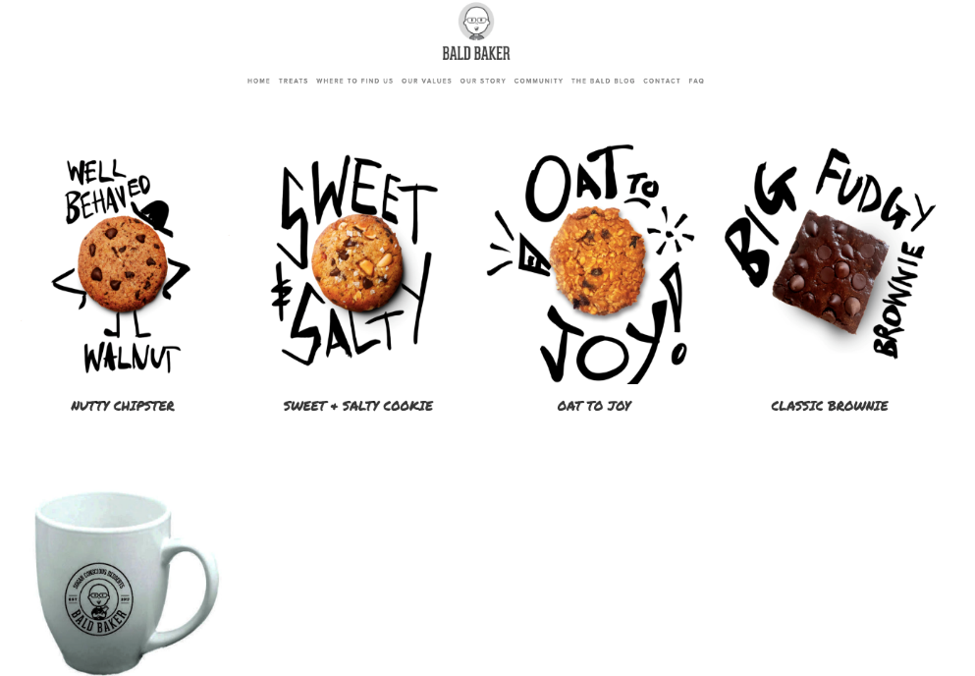

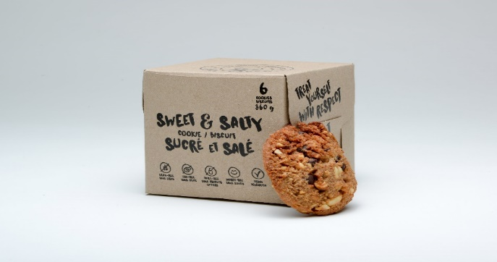

Kraft Box

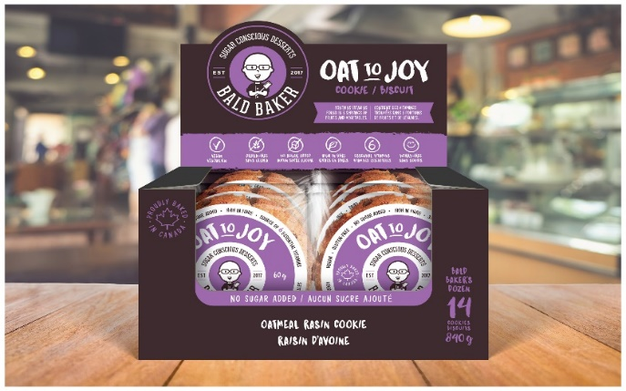

Retail Box

Exhibit 1 (Continued)

Nutty Chipster Cookie Sweet & Salty Cookie Big Fudgy Brownie

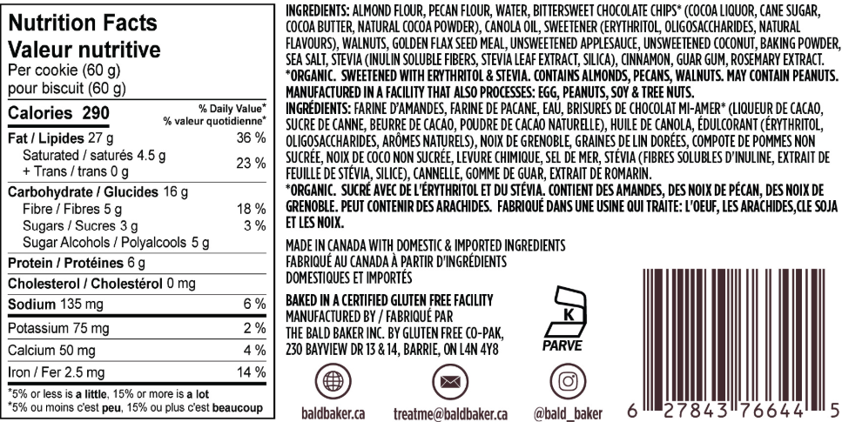Sweet & Salty Nutrition FactsBig Fudgy Brownie Nutrition Facts

Exhibit 1 (Continued)

Oat to Joy Cookie

Oat to Joy Nutrition Information

Source: Company files.

Exhibit 2: competiton analysis

| **Companies** | **Founded** | **Head Office** | **Number of Employees in 2018** | **Revenue in 2018 ($CA)** | **Retail Price Range ($CA) per pack** | **Distribution Channels** | **Online Sales** |
| --- | --- | --- | --- | --- | --- | --- | --- |
| Sweets from the Earth | 2002 | Toronto | 53 | $1.0 million | $1.49−  $2.99 | Grocery stores, specialty stores, and coffee shops | Yes |
| New Moon Kitchen | 1997 | Toronto | 11 | $2.0 million | $1.49−  $2.50 | Specialty stores and coffee shops | Yes |
| Shockingly Healthy | 2013 | Toronto | 33 | $3.3 million | $2.00−  $2.99 | Specialty stores, convenience stores, whole foods stores, and coffee shops | Yes |
| Bald Baker | 2016 | Toronto | 2 | $100,000 | $2.69−  $2.99 | Specialty stores and special programs in grocery stores | Yes |

Source: Created by the authors based on information provided on Sweets from the Earth (website), accessed March 10, 2021, <https://sweetsfromtheearth.com/>; “New Moon Kitchen,” New Moon Cookies, accessed March 10, 2021, <https://newmooncookies.com/>; Shockingly Healthy (website), accessed March 10, 2021, <http://shockinglyhealthy.com/>; CB Staff, “2018 – 252 – Sweets from the Earth,” *Canadian Business*, September 9, 2018, accessed March 10, 2021, <https://www.canadianbusiness.com/lists-and-rankings/growth-500/2018-252-sweets-from-the-earth/>; “New Moon Kitchen,” ZoomInfo, accessed March 10, 2021, <https://www.zoominfo.com/c/new-moon-kitchen/346890000>; “Sweets from the Earth,” Owler, accessed March 10, 2021, <https://www.owler.com/company/sweetsfromtheearth>.

Exhibit 3: Bald Baker Company Sales and revenue*

|  | **Bald Baker Units Sold** | |
| --- | --- | --- |
|  | **2017** | **2018** |
| Retail Boxes |  |  |
| Classic Brownie | - | 1,110 |
| Nutty Chipster | - | 1,750 |
| Oat to Joy | - | 600 |
| Sweet & Salty | - | 1,080 |
| Total Retail Boxes Sold | - | 4,540 |
|  |  |  |
| Kraft Boxes |  |  |
| Classic Brownie | 50 | 650 |
| Nutty Chipster | 500 | 950 |
| Oat to Joy | - | 10 |
| Sweet & Salty | 380 | 850 |
| Total Kraft Boxes Sold | 930 | 2,460 |

|  | **Bald Baker Revenue** (CA$)** | |
| --- | --- | --- |
|  | **2017** | **2018** |
| Retail Boxes |  |  |
| Classic Brownie | - | $ 11,588.40 |
| Nutty Chipster | - | $ 18,270.00 |
| Oat to Joy | - | $ 6,264.00 |
| Sweet & Salty | - | $ 11,275.20 |
| Total | - | $ 47,397.60 |
|  |  |  |
| Kraft Boxes |  |  |
| Classic Brownie | $ 1,218.00 | $ 15,834.00 |
| Nutty Chipster | $ 12,180.00 | $ 23,142.00 |
| Oat to Joy | - | $ 243.60 |
| Sweet & Salty | $ 9,256.80 | $ 20,706.00 |
| Total | $ 22,654.80 | $ 59,925.60 |
|  |  |  |
| Total Revenue: | $ 22,654.80 | $ 107,323.20 |

Note: *At the request of Dan Sennet, Bald Baker’s chief executive officer, all numbers in the exhibits have been disguised. **Revenue was calculated based on 40% featured and 60% regular price.

Source: Company files.

1. All dollar amounts in the case are in Canadian dollars unless specified otherwise.
2. Medical Associates of Northwest Arkansas, “Sugar Awareness for Parents,” MANA Medical Associates, accessed January 12, 2021, https://www.mana.md/sugar-awareness-month/.
3. Daniela Coppola, “Sales Value of Cookies in Canada from 2013 to 2018 (in Million Canadian Dollars)*,” Statista, November 30, 2020, accessed March 10, 2021, https://www.statista.com/statistics/460751/retail-sales-of-cookies-canada/.
4. “Nielson: Dollar Share for Plant-Based Proteins Grows in North America,” Innovopro, August 1, 2018, accessed April 27, 2021, https://innovopro.com/nielson-dollar-share-for-plant-based-proteins-grows-in-north-america//.
5. Dr. Lauren Panoff, “What’s the Difference between a Plant-based and Vegan Diet?,” EcoWatch, March 14, 2020, accessed January 12, 2021, https://www.ecowatch.com/plant-based-vs-vegan-diet-2645486232.html?rebelltitem=2#rebelltitem2.
6. “Global Sugar-Free Food and Beverages Market Size to Reach USD 72.37 Billion by 2021: Technavio,” Business Wire, March 1, 2017, accessed January 13, 2021, https://www.businesswire.com/news/home/20170301005073/en/Global-Sugar-free-Food-and-Beverages-Market-Size-to-Reach-USD-72.37-Billion-by-2021-Technavio.
7. Carole L. Hart, David J. Hole, Debbie A. Lawlor, and George Davey Smith, “How Many Cases of Type 2 Diabetes Mellitus Are Due to Being Overweight in Middle Age? Evidence from the Midspan Prospective Cohort Studies Using Mention of Diabetes Mellitus on Hospital Discharge or Death Records,” *Diabetic Medicine* 24, no. 10 (2007): 73−80. doi:[10.1111/j.1464-5491.2007.02016.x](https://doi.org/10.1111/j.1464-5491.2007.02016.x).
8. “Report Indicates Urgent Changes by Government Are Needed to Support People with Diabetes in Ontario,” Diabetes Canada, December 15, 2017, accessed January 13, 2021, https://www.diabetes.ca/media-room/press-releases/report-indicates-urgent-changes-by-government-are-needed-to-support-people-with-diabetes-in-ontario.
9. James J. DiNicolantonio, James H. O’Keefe, and William L. Wilson, “Sugar Addiction: Is It Real? A Narrative Review,” *British Journal of Sports Medicine* 52, no. 14 (July 2018): 910−913.
10. Marina Komaroff, “For Researchers on Obesity: Historical Review of Extra Body Weight Definitions,” *Journal of Obesity* 2016 (2016).
11. Jon Johnson, “What Are Monk Fruit and Stevia?,” Medical News Today, August 15, 2018, accessed November 27, 2020, https://www.medicalnewstoday.com/articles/322769.php.
12. At the time of writing the case, there was no indication whether these ingredients would be legalized in the coming years.
13. Peter Leighton, “Marketing Healthy Snacks,” Natural Products Insider, September 1, 2016, accessed January 13, 2021, https://www.naturalproductsinsider.com/branding-marketing/marketing-healthy-snacks.
14. Sweets from the Earth (website), accessed January 13, 2021, https://sweetsfromtheearth.com/.
15. “New Moon Kitchen,” New Moon Cookies, accessed January 13, 2021, https://newmooncookies.com/.
16. Shockingly Healthy (website), accessed January 13, 2021, http://shockinglyhealthy.com/.
17. “Sweets from the Earth is Named One of Canada’s Fasting Growing Companies!,” Sweets from the Earth, September 18, 2018, accessed January 13, 2021, https://sweetsfromtheearth.com/sweets-from-the-earth-is-named-one-of-canadas-fastest-growing-companies-2/.
18. “Our Story,” Sweets from the Earth, accessed January 13, 2021, <https://sweetsfromtheearth.com/about-us/our-story/>.
19. “What’s So Special About Our Cookies?,” New Moon Cookies, accessed January 13, 2021, <https://newmooncookies.com/pages/whats-so-special-about-our-cookies>.
20. “How It All Began,” New Moon Cookies, accessed January 13, 2021, <https://newmooncookies.com/pages/about-us>.
21. “Our Values,” Shockingly Healthy, accessed January 13, 2021, <http://shockinglyhealthy.com/our-values/>.
22. “Products,” Shockingly Healthy, accessed January 13, 2021, <http://shockinglyhealthy.com/products/>.
23. The price range was obtained from Sweets from the Earth (website), op. cit.; “New Moon Kitchen,” op. cit.; Shockingly Healthy (website), op. cit.
24. Food distributors were intermediaries that collected food from producers and distributed it to grocery stores, restaurants, coffee shops, and other retailers.